**Synthesis and Characterization of mixed Ligand Complexes with Some Transition Metals using both Conventional and Microwave methods and Studying them Theoretically**

***Sahar Ismael Imran***

E- mail:- [sa7arqxq@gmail.com](mailto:sa7arqxq@gmail.com)

Department of Chemistry\College of Science \University of Baghdad

Baghdad-Iraq

**ABSTRACT** : New mixed ligand complexes have been prepared by the reaction of Quinoline- 2-Carboxylic acid (L1) and 2,2**\**-Bipyridine (L2)with Co(II),Ni(II) using both Conventional and Microwave methods. The newly prepared complexes were isolated and characterized by (FT-IR) and (UV-Vis) spectroscopy, elemental analysis, Flame Atomic Absorption technique, Thermo Gravimetric Analysis, in addition to Magnetic Susceptibility and Conductivity measurements. A theoretical treatment of these ligands and the newly prepared complexes in gas phase were investigated using two programs HyperChem Professional 8.0 and Gaussian program ( GaussView Available Versions (5.0.9) along with Gaussian 09) .

**Keywords: Quinoline-2-Carboxylic acid, 2,2\-Bipyridine, HyperChem Professional 8.0. ,Gaussian program, Microwave method.**

**1. INTRODUCTION**

Quinoline Carboxylic acid and their analogues show wide variety of medicinal properties including antitumor [1], antiviral [2] and estrogenic activity [3]. Recent demonstrations reveal that Quinoline-2-Carboxylic acid can be used as potential anticancer agents [4], and a biological compound involved in the metabolism of tryptophan. It is a strong chelator providing donor set similar to that responsible for binding metal ion in PQQ (pyrroloquinilnequinone) cofactor of quinoprotein family [5].

Bipyridines (IUPAC), also known as bipyridyls, dipyridyls and dipyridines, are aromatic nitrogen heterocycles that form complexes with most transition metals. This class of compounds contains six possible regioisomers 2,2**\**; 2,3**\**; 2,4**\** ; 3,3**\**; 3,4**\** and 4,4**\** as shown in **Figure (1).** The most common of which is the bidentate chelate, (bpy =2,2**\**-bipyridine). Bipyridine ligands interact with metals via both σ-donating nitrogen atoms and π-accepting molecular orbitals[6].

The bi-dentate N,N chelating agents as 2,2**\**-Bipyridine are deeply investigated, and was found to possess a vital role in synthetic and medicinal chemistry. 2,2\-Bipyridal has been used to prepare many mixed-ligand complexes. Different ligand complexes prepared from 2,2**\**-Bipyridine are used in different areas such as molecular catalysis, solar energy conversion, calorimetric analysis, herbicides, molecular recognition,self-assembly, antineoplastic agents, and nucleic acid probes. Another important property of these types of compounds is the triplet state photosensitizing character of bipyridyl nucleus, which is shown in metal complexes [7-8].



***Figure (1): Six Possible Regioisomers of Bipyridine.***

Quinoline-2-Carboxylic acid and the co-ligand 2,2\-Bipyridine did not receive any attention in spite of well-defined applications of both the molecules. Hence it was thought to explore the synthesis and characterization of some new Co(II), Ni(II) complexes with Quinoline-2-Carboxylic acid and the co-ligand 2,2\ -Bipyridine as mixed ligand complexes using both Conventional and Microwave method. Moreover, the newly designed complexes deeply investigated by using different available techniques. Finally, theoretical treatments of these ligands and the newly prepared complexes in gas phase have been studied using two programs hyper chem.8 and Gaussian program.

**2. Chelate and Chelate Effect**

The chelate describes the compounds in which the groups/molecules/atoms present in a ligand bonded with central metal atom at two or more points. The process of chelation involves coordination of more than one sigma-electron pair donor group from the same ligand to a single central atom. The terms, monodentate, bi/di-dentate and polydentate ligands is used to describe the number of donating groups/molecules/atoms found in ligands, ligands with more than two donating groups are bolydentate. The stability factor in chelates depends on the followings:

* Size and number of rings
* Substituents present on the rings
* The metal and the donor atoms nature of.

In the macrocyclic complexes, the degree to which the size of metal ion fits the space enclosed by the macro rings is a significant factor [9].

**3. Microwaves as Green Chemistry Approach**.

Recently, "green chemistry" processes gained huge attention, because the method proved to diminish the generation of hazardous substances. As a result Synthetic chemists aimed at "Atom-economy" of chemical reactions by developing several valuable and distinctive techniques as key concepts of green and sustainable chemistry.Elimination of volatile organic solvents in organic synthesis is one of the most important goals in green chemistry. Solvent free organic reactions make synthesis simpler, save energy and prevent solvent wastes, hazards and toxicity [10].The typical bands for industrial applications of microwave are 915±15 and 2450±50 MHz. To our knowledge, all the reported microwave chemistry experiments are currently conducted at 2450MHz (the corresponding wavelength is 12.24 cm), because at this frequency, the microwave energy absorption by liquid water is maximal, also the 2450 MHz magnetrons are mostly often used in the available commercial microwave chemistry equipment [11].

**4.** **Experimental:**

**4.1 Material and instrumentation:**

Metal salts of (Co(NO3)2.6H2O and Ni(NO3)2.6H2O were obtained from Fulka ,B.D.H and Merk in high purity , Quinaldic acid and 2,2**\**-Bipyridine from Merk and E.Merk ,while Ethanol (absolute) and Dimethyl formamide was obtained from B.D.H. Modified microwave oven model 2001 ETB with rotating tray and a power source 230 V, microwave energy output 800W and microwave frequency 2450 MHz. used in the current work.

**4.2** **Physical measurements and analysis:**

Melting point was recorded by Gallen Kamp melting point apparatus. FT-IR spectra were recorded as CsI discs using FT-IR.3800 Shimadzu in the range of (4000-200cm-1). Electronic spectra were obtained using Uv-1650 PC Shimadzu Spectrophotometer at room temperature in DMF solvant. Conductivity was measured by capacitor analyzer and in DMF solution (10-3 M) at room temperature .Elemental analysis was performed by using EM-017 mth instrument. Magnetic susceptibility measurements were obtained at 25 0C Magnetic Susceptibility Balance of Johnson matty catalytic system division, England. The metal percent of the complexes were determined by using GBS-933 Flam. The thermal analysis of the prepared complexes have been carried out by Perkin Elmer TGA 4000 instrument in heat ranges from 30.00 0C to 900.00 0C at heating rate 20.000C . Helium was used as inert gas. Microwave assisted synthesis were carried out in open glass vessel on a modified microwave oven model 2001 ETB with rotating tray and a power source 230 V, microwave energy output 800W and microwave frequency 2450 MHz. A thermocouple device was used to monitor the temperature inside the vessel of the microwave. The microwave reactions were performed using on/off cycling to control the temperature.

**4.3. General method for preparation of the Complexes:**

**1**. **Conventional Method**

The solution containing primary ligand Quinoline-2-Carboxylic acid in 10 ml ethanol and a secondary ligand 2,2**\**-Bipyridine in 5 ml ethanol were added to a warm solution of metal salts Co(NO3)2.6H2O and Ni(NO3)2.6H2O in 5 ml of absolute ethanol in molar ratio 1:1:1. The mixture heated and refluxed with stirring for (3-4) hrs. The colored precipitates were filtered, washed several times with Ethanol, then Ether, and finally dried under the vacuum.

**2.** **Microwave Method**

The primary ligand Quinoline-2-Carboxylic (L1 ) and the secondary ligand (2,2\-Bipyridine) (L2) and the metal salts (1 mmole) [Co(NO3)2.6H2O and Ni(NO3)2.6H2O ] were mixed in 1:1:1 ( M: L1: L2) ratio in a grinder. Then the mixture was irradiated in the microwave oven using few drops of solvent. The reaction was completed in a short time (1.40-2.10) min or (100-130) sec. The resulting products then re-crystallized with ethanol and ether and finally dried under vacuum. Some physical properties for the newly colored and solid participates are shown in**Table (1).**

**5. Results and Discussion:** Some physical properties and data of the Ligands (L1) and (L2) with their metal complexes prepared by conventional method are given in **Table (1).** The low values of molar conductivity (Ω) in DMF indicate the non electrolyte behavior of these complexes.

As a result of microwave assisted synthesis, it was observed that the reaction was completed in a short time with higher yields compared to the conventional method. In the microwave method homogeneity of reaction mixture was increased by the rotating of reaction platform tray. The confirming of the results was also checked by the repeating the synthesis process; this particular step also helped to set the best time of complexes’ formation, **Table (1).** In **Table (2)** and **Table (3)** shows the percent composition of CoL1L2 and NiL1L2 complexes using mass fraction tool.

**Table (1): Some Physical and Analytical Data for the Ligands and their Metal Complexes Prepared by Conventional and Microwave Methods.**

|  |  |  |  |  |  |  |  |  |  |  |  |  |  |
| --- | --- | --- | --- | --- | --- | --- | --- | --- | --- | --- | --- | --- | --- |
| **Comp.** | **Color** | **M.P**  **OC**  **CM**  **(MM)** | **Reaction Time** | | **Yield%** | | **M.Wt**  **g.mol-1** | **Elemental anylasis**  **Found (Calc.)** | | | | **Metal**  **percentage** | |
| **C** | **H** | **N** | **S** | **Cal.** | **found** |
| **CM**  **Hr.** | **(MM)**  **Min.** | **CM** | **(MM)** |
| **L1** | White | **156** | ***___*** | ***____*** | ***------*** | ***____*** | **173.17** | ***____*** | ***____*** | ***____*** | ***__*** | ***____*** | ***___*** |
| **L2** | White | **74** | ***___*** | ***___*** | ***------*** | ***____*** | **156.19** | ***--------*** | ***-------*** | ***-------*** | ***---*** | ***___*** | **___** |
| **CoL1L2** | Greenish  blue | **86**  **(87d)** | **4.0** | **2.10** | **77.46** | **92.54** | **484.55** | **(49.41)** | **(3.29)** | **(11.52)** | ***---*** | **11.68** | **12.10** |
| **NiL1L2** | Light green | **127**  **(131d)** | **4.0** | **1.40** | **80.41** | **97.82** | **530.07** | **(45.31)** | **(4.21)** | **(11.77)** | ***---*** | **11.07** | **11.12** |

**\*CM = Conventional Method, (MM) = Microwave Method**

**Table (2): Percent Composition of CoL1L2 Using Mass Fraction Tool.**

|  |  |
| --- | --- |
| **| number\nof atoms | mass fraction | atom fraction\n C (carbon) | 20 | 49.394% | 39.2%\n Co (cobalt) | 1 | 12.118% | 2.0%\n H (hydrogen) | 19 | 3.938% | 37.3%\n N (nitrogen) | 4 | 11.521% | 7.8%\n O (oxygen) | 7 | 23.029% | 13.7%** | http://www4f.wolframalpha.com/Calculate/MSP/MSP83591d1g52105252833f00004981234hc8if3icd?MSPStoreType=image/gif&s=12&w=127.&h=100.&cdf=ResizeableMass Fraction Pie Chart for CoL1L2 Complex |

**Table (3): Percent Composition of NiL1L2 Using Mass Fraction Tool.**

|  |  |
| --- | --- |
| **| number\nof atoms | mass fraction | atom fraction\n C (carbon) | 20 | 45.317% | 38.5%\n H (hydrogen) | 17 | 3.233% | 32.7%\n N (nitrogen) | 5 | 13.212% | 9.6%\n Ni (nickel) | 1 | 11.073% | 1.9%\n O (oxygen) | 9 | 27.165% | 17.3%** | http://www4f.wolframalpha.com/Calculate/MSP/MSP83591d1g52105252833f00004981234hc8if3icd?MSPStoreType=image/gif&s=12&w=127.&h=100.&cdf=ResizeableMass Fraction Pie Chart for NiL1L2 Complex |

**5.1 Infrared spectral studies:**

**Table** **(4)** shows the tentative assignments of the IR peaks for the free Qinoline -2- carboxylic acid together with the co-ligand 2,2**\**-Bipyridine . The (L1) may coordinate with metal ions through monodentate, bidentate chelating and bridging according to Nakamoto (2009) and Deacon & Phillips (1980) [12,13].The infrared spectrum of the solid state 2-Quinaldic Acid indicates two tautomeric forms of (L1) at the same time, as a neutral molecule (Quinoline-2-Carboxylic Acid) and as a zwitter ion (Quinolinium-2-Carboxylate) [14] .IR spectrum of the ligand, shows a typical broad band in the range (3417-2534)cm-1 with its maximum at (2939) cm-1 which refers to stretching frequency of ν(O-H) of carboxylic acid (Nakamato 2009) [13] ,this can still be observed in the IR spectrum of Nickel complex ,this confirmed the incomplete deprotonation of ligand (Qin et al. 2005; Yong et al. 2004)[15]. On the other hand, the absence of absorption bands in this region in IR spectra for Cobalt complex confirmed the complete deprotonation of the ligand in these complexes (Du et al. 2008; Zhang et al. 2006)[16].Further confirmation comes from the absence of C-O-H bending peak for COOH group at 908 cm-1 (Ye et al. 2005; Zhang et al. 2008)[17]. In order to predict the coordination mode of metal ions with Qinoline-2-carboxylic acid, we compared the difference of the value between the asymmetric and symmetric stretching of COO- frequencies (Δν = **ν**symCOO-_**ν**asym COO**-**) of all complexes. As in **Table (4)**,

The difference between **ν**symCOO**-** and **ν**asym COO**-**, Δν valus, for each prepared complexes, indicating the monodentate coordination of the carboxylate group as in **Table (4)** ,other very weak intra- and intermolecular interactions can’t be excluded, and the bending of δ (C=N) in all complexes shifted and appeared at the range (408-393) cm-1 with its maximum at (405) cm-1 **[18]**this indicate that the nitrogen atom of quinoline-2-carboxylic acid also had coordinated with metal ions. Furthermore, a new bands attributed to ν (M-O) and ν (M-N) which appeared at (570-520) cm-1 and (420-489)cm-1 respectively in both complexes further confirmed QHhad coordinated with the metal ions through oxygen atom of carboxylate group and nitrogen atom (Nakamoto 2009)[13] The coordination of 2,2\-Bipyridine is indicated by the positive shift of ν(C=C) and ν(C=N) ring streching frequencies and the presence of their deformation modes at 1168 and 1936cm-1. The position of the bands found in the spectrum of 2,2\-Bipyridine has been completely changed in the spectra of the complexes, co-ligand new bands appeared at ~1560-1590 cm-1 confirming the coordination nature of this ligand, the 424 cm-1 band of 2,2\-Bipyridine (C-C out of plane bending) shifts to higher frequency and splits into two components in the complexes which again confirms the coordination of this ligand through two nitrogen[14]. An additional band in the range (260-270) cm-1 has been also observed in both complexes indicating 2,2\-Bipyridine nitrogen coordination with metal ion [19]. The presence of water molecules causes the appearance of a broad O-H stretching bands in the region of 3473-3417 cm-1 in IR spectra of the complexes(Cho et al. 2003; Zhai et al. 2006)[20] and shown below in **Figures [2-5]**.

**Table (4) Main FTIR bands in (cm -1) observed in the spectra of metal ions mixed ligands complexes**

|  |  |  |  |  |  |  |  |  |
| --- | --- | --- | --- | --- | --- | --- | --- | --- |
| **Comp.** | **νasy.COO_** | **νsym.COO_** | **νC=O** | **νC=N+νC=C** | **νM-N** | **νM-O** | **νM-N**  **bipy** | **Others** |
| **L1 Qin** | 1580 | 1390 | 127 | 1604,1535,1508,  1473 | ---- | ---- | ---- | ---- |
| **L2 Bipy.** | ---- | ---- | ---- | 1604,1519,1481,  1450 | ---- | ---- | ---- | ---- |
| **CoL1L2** | 1592 | 1384 | ---- | 1612,1562,1512,  1462 | 443 | 570 | 263 | **νOH=3439**  **δH2O=848.6**  **NO3=1400(sh),1176,941** |
| **NiL1L2** | 1595 | 1394 | 123 | 1612,1560,1512,  1465 | 489 | 528 | 270 | **νOH=3402**  **δH2O=856**  **NO3=1416,1176,968** |

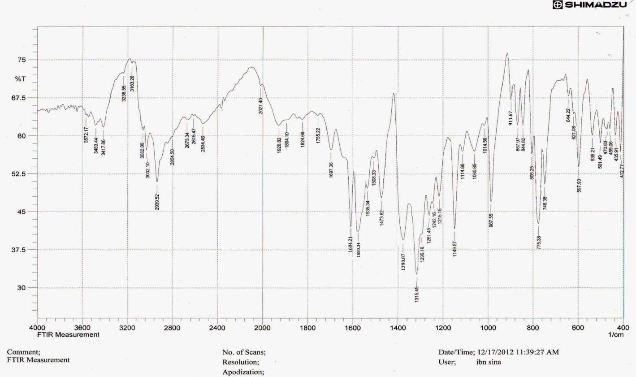

***Figure (2): FTIR Spectrum of Quinoline-2-carboxylic***

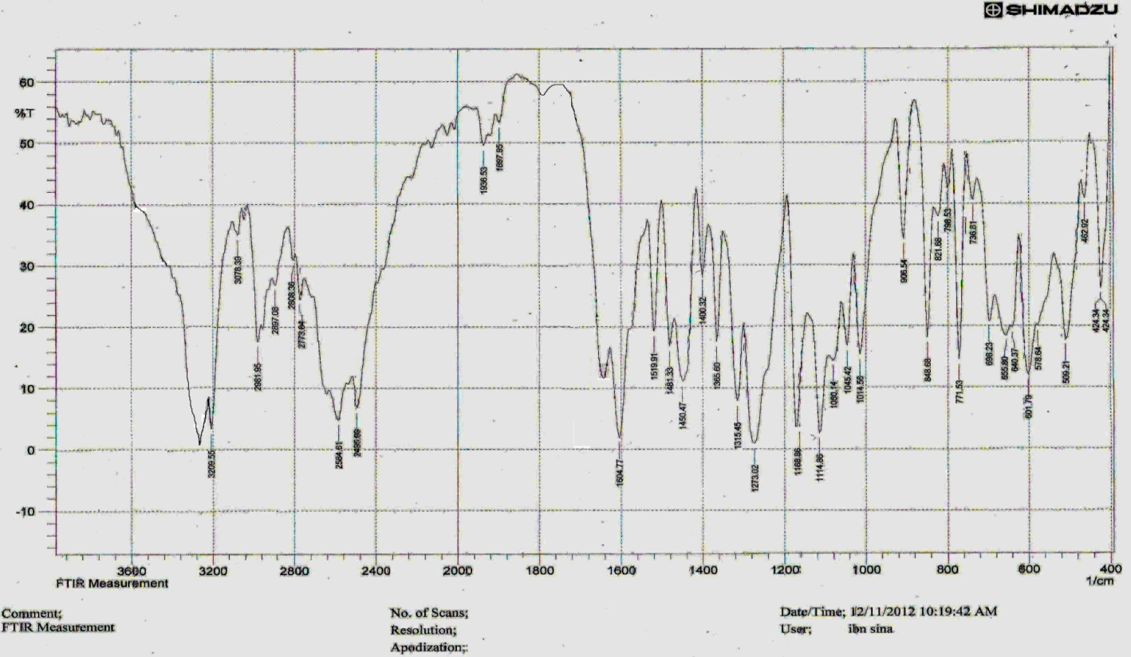

***Figure (3): FTIR Spectrum of 2,2\-Bipyridine***

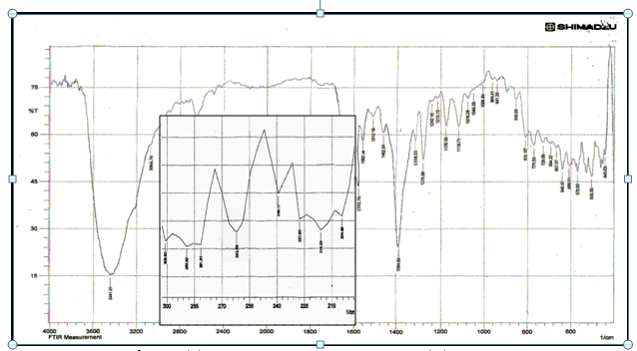***Figure (4): FTIR Spectrum of Cobalt (II) complex***

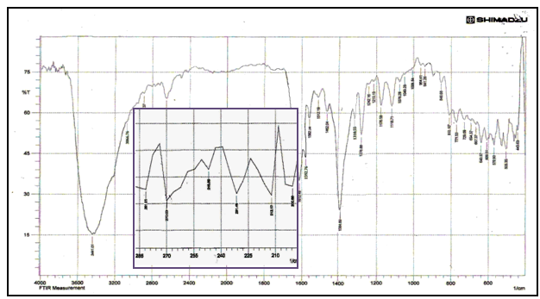***Figure (5): FTIR Spectrum of Nickel (II) complex***

**5.2 Magnetic properties:**

The magnetic moment (μeff ) for the Cobalt (II) complex (d7) were found to be (4.36)B.M , this higher value of (μeff ) in this complex may be due to orbital contribution of spin orbital coupling .In Nickel (II) complex it was recorded at (3.11) B.M. The magnetic moment value increased as expected due to un regular geometry of the complex and the presence of contribution spin orbital coupling.

**5.3 The Electronic Spectra and conductance in DMF :**

**5.3.1 The Electronic Spectera of ligands**

The electronic spectrum of L1 exhibits Four main bands appeared at 45045 cm-1 due to (π-π*) , 41666 cm-1 due to interaligand (n-π*) transition, and 34843 due to (n-π* ) transition, and a shoulder band at 328 nm 30487 cm-1 due to (n-π*) transition [15] .While the Electronic spectrum of L2 in exhibits two main bands the first appeared at 41352 cm -1 due to interaligand (π-π*) transition. The second absorption appeared at 33070 cm -1 arises from (n-π*) transition that may be located on nitrogen atom of –N=C-. A comparative look of electronic absorption spectral data of the ligands and their complexes indicate that n-π and π-π* transition of the ligands have shifted to higher frequencies[21], **Table(5).**

**5.3.2Electronic Spectra of [Co (L1)(L2)] Complex:**

The greenish -blue complex showed three bands at 16573cm-1, 16447,and 14939 cm -1  which assigned to 4A2→4T1p ν3 transition .This is transition is known to be triplet in the divalent cobalt of tetrahedral geometry. This splitting is due to spin orbital coupling **[22]** therefore, ν3 has been calculatedas the average of these three bands.

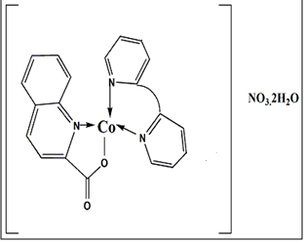

While ν1 (4A2→4T2 ),and ν2 (4A2→4T1 ), couldn’t be seen since which expected to appear in the range out of instrument scale, so the second transition (ν2 ) calculated theoretically from using Tanabe–Sugano diagram for d7 system and was found to be ( 5389) cm -1,while first transition (ν1 ) calculated from infrared spectrum and found to be (3439) cm-1 ,moreover, B**⁄** ,Dq,and β were calculated by using ***d7*** Tanabe-Sugano diagram and the low value of (β) indicate that the bond is covalent. These parameters are accepted for Cobalt (II) Tetrahedral complexes [23], **Table(5)**.

**5.3.3 Electronic Spectra of [Ni (L1)(L2)] Complexes:**

The electronic spectrum of nickel (II) complex showed three bands , 9813 cm-1, 14678 cm-1 , and30201 cm-1 which assigned to 3A2g→3T2g , 3A2g→3T1g, and3A2g→3T1g(p) respectively**.** The spectrum also showed a band at 13329 cm-1 corresponds to 3A2g→1Eg which is forbidden. These bands indicate an octahedral geometry around Ni(II) ion **[24]**,alsothe absence of the frequency at(20000)cm-1 prove that the prepared complex is not square planer **[25]** ,a weak band is observed at 9813 cm-1 which suggest that the complex having octahedral geometry**[26] .**The value is approximately equal to 10Dq, nephelauxetic factor *β* and Racah parameter B**⁄** were calculated by fitting the ratio ν3/ν2 to the Tanabe-Sugano diagram for d8 system **Table(5)**

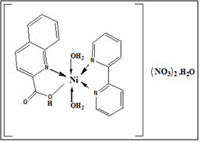 By fitting the ratio of frequencies (ν 2/ ν1) which equal to 1.48 indicates that the complex having distorted octahedral geometry**[27]** .Comparable the value of a regular geometry which equals to 1.6 [28] the degree of distortion has been calculated using the following equation and found that λ=(-245. 7) cm-1 **obs=s.o** The formula is further confirmed to be ionic by conductivity measurements. From these results and the data obtained from atomic absorption analysis, infrared spectra, elemental analysis and thermal analysis, an octahedral geometry around Ni (II) ion can be proposed.

**Tabe(5): Electronic Spectra , conductance in DMF solvant and magnetic moment (B.M) for the ligands and their metal complexes**

|  |  |  |  |  |  |  |  |  |  |  |  |
| --- | --- | --- | --- | --- | --- | --- | --- | --- | --- | --- | --- |
| **Comp.** | **Absorption** | **Assignment** | **Bо** | **B\** | ***β*** | **Dq/B\** | **10Dq** | **15 B\**  **term** |  | ***s*cm*-1*** | **Suggested**  **Structure** |
| **L1** | **30487sh**  **34843**  **41666**  **45o45** | **n→π\***  **n→π\***  **n→π\***  **π→π\*** | ----- | ------ | ----- | ----- | ----- | ------ | ----- | ------ | ----- |
| **L2** | **33070**  **41352** | **n→π\***  **π→π\*** | ----- | ------ | ----- | ----- | ----- | ------ | ----- | ------ | ----- |
| **CoL1L2** | **3439**  **5389(cal.)**  **15997(av.)** | **4A2→4T2**  **4A2g→4T1**  **4A2g→4T1P** | **974** | **741.5** | **0.76** | **0.46** | **3463** | **11067** | **4.32** | **76.6** | **Td** |
| **NiL1L2** | **13329**  **9813**  **14682**  **30201** | ***3*A2g→1Eg**  **3A2g→3T2g**  **A2g→3T1g**  **3A2g→3T1g** | **1030** | **911.6** | **0.85** | **1.09** | **9884** | **989.9** | **3.11** | **72.4** | **Oh** |

**ILCT: Internal ligand charge transfer, sh: Shoulder**

**5.4 Thermal analysis**

**5.4.1[CoL1L2]NO3.2H2O Complex**

The data obtained indicate that the [CoL1L2]NO3.2H2O complex is thermally stable in the temperature 118.93 οC. Decomposition of [CoL1L2]NO3.2H2O complex start at 94οC and finished at 656.42 οC. with three stages. The first stage is accompanied by weight loss of 6.78%, corresponding to the loss of two water molecules (7.86 %cal) ,**Table(6).**

**5.4.2 [NiL1L2(H2O)2](NO3)2.H2O Complex**

The complex is thermally stable up to 129.65 οC. The compounds decompose in five endothermic steps. The first step is dehydration process three water molecules moisture absorbed by complex and coordinated water molecule (observed weight loss 8.84%, calculated 9.21%) are released at 129.65-170.22 οC (peak at DTA curve), **Table(6).**

**Table (6): Thermal analytical data of the water molecule for the newly prepared complexes**

|  |  |  |
| --- | --- | --- |
| **Compunds** | **Weight loss %** | |
| **Found** | **(Calculated)** |
| **CoL1L2** | **6.78** | **6.86** |
| **NiL1L2** | **8.84** | **9.21** |

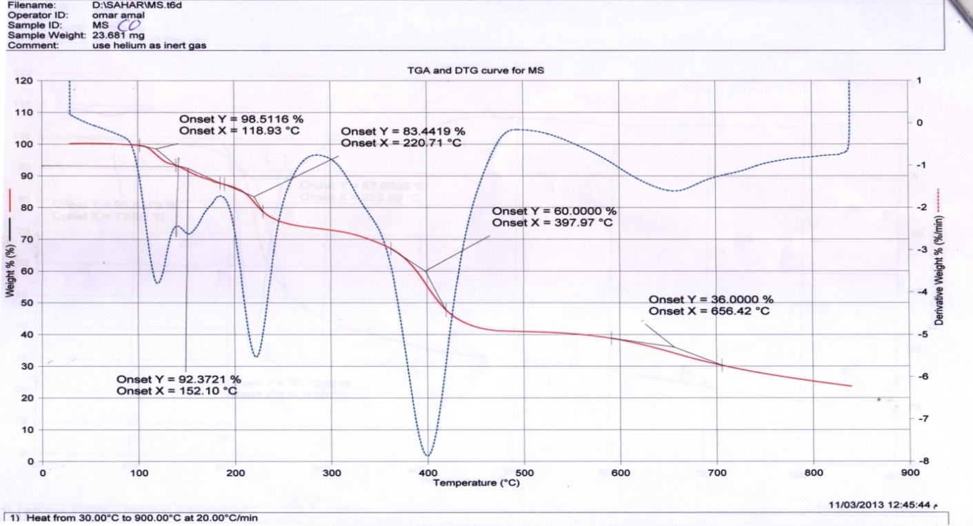

***Figure (6): TG and DTG curve of Cobalt (II) complex***

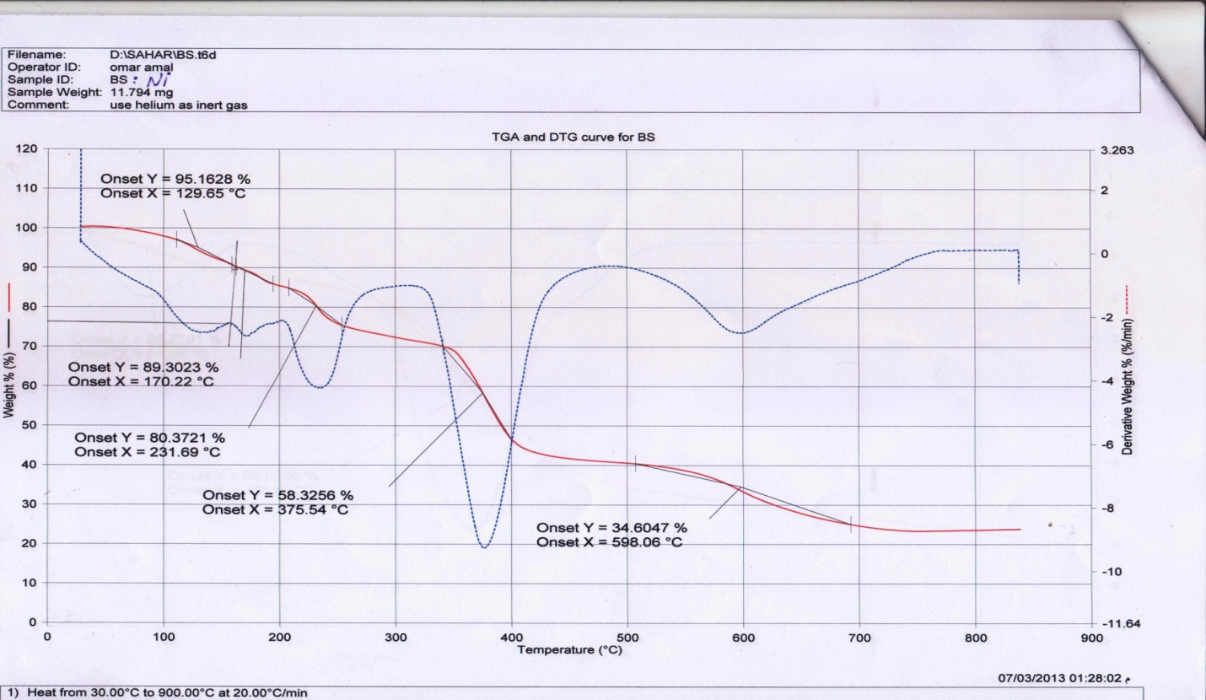

***Figure (7): TG and DTG curve of Ni (II) complex***

**6. Theoretical studies:**

In this work Hyper chem.-8program used the molecular mechanics and semi-empirical calculation. the heat of formation (ΔHоf), binding energy (ΔEb) and dipole moment (µ) for the free ligands and their metal complexes were calculated using ZINDO/I, PM3 and AMBER methods at 298 K . It was found that the complexes are more stable than their ligands **Table (7);** While Gaussian program used semi-empirical (PM3) method to calculate :the Geometry optimization, Dipole moment (μ), total energy for ligands **Table (8).**

In **HyperChem-8.** PM3 was used to evaluate the vibrational spectra of free ligands ,and these obtained frequencies agreed well with those values experimentally found ,in addition, the calculation helped to assign unambiguously the most diagnostic bands,While in **Gaussian program** it was found that the vibrational spectra of free ligands ,and these obtained frequencies agreed well with those values experimentally as shown in **Table (9).**

Electronic spectra measurements for the ligands were calculated theoretically by using ZINDO/S method in **HyperChem-8**. and comparing it with the experimental results. It was found that there was a close agreement between the theoretical and experimental spectra **Table (10).**In **Gaussian program** electronic spectra measurements for the ligands were calculated theoretically by using The job type: Single point energy (SP) along with ZINDO method and also The job type Frequency (Freq) used along with CIS method (3-21G), comparing both methods with the experimental results It was found that there was a close agreement between the theoretical and experimental spectra **Table (10).**

Furthermore, the electrostatic potential of free ligands was calculated in both barograms to investigate the reactive site of the molecules, along with ELUMO and EHOMO was obtained, See **Figures [6,7].**

**Table (7): Conformation Energetic in(Kcal.mol-1) and Dipole Moment (inDebye) for Ligands and their Metal Complexes using HyperChem-8. program.**

|  |  |  |  |  |  |  |  |
| --- | --- | --- | --- | --- | --- | --- | --- |
| **Compound** | ***PM3*** | | | ***ZINDO/1*** | | | ***AMBER*** |
| ***ΔHоf*** | ***ΔEb*** | ***µ*** | ***ΔHоf*** | ***ΔEb*** | ***µ*** | ***ΔHоf=ΔEb*** |
| **L1** | **-39.8326** | **-2345.56** | **3.027** | **-4515.74** | **-6821.47** | **3.324** | **----------** |
| **L2** | **329.69** | **-2259.59** | **4.589** | **-4860.72** | **-7450.01** | **5.209** | **----------** |
| **Co L1L2** | **--------** | **---------** | **------** | **-10216.87** | **-15474.80** | **13.84** | **----------** |
| **Ni L1L2** | **--------** | **---------** | **------** | **-10993.76** | **-16631.72** | **8.291** |  |

**Table (8): Conformation Energetic in(Kcal.mol-1) and Dipole Moment (in Debye) for Ligands (L1,L2) using Gaussian program.**

|  |  |  |
| --- | --- | --- |
| **Compound** | **Total energy** | **µ** |
| **L1** | **-32.44762449** | **3.3846** |
| **L2** | **45.4167809** | **3.4377** |

**Table (9): Comparison of Experimental and Theoretical main Vibration Frequencies for Qinoline-2-Carboxylic Acid (L1) and 2,2\-Bipyridine (L2) using both HyperChem-8. and Gaussian Programs**

|  |  |  |  |  |  |
| --- | --- | --- | --- | --- | --- |
| **HyperChem-8** | **Symb.** | **ν(C=O)** | **ν(C=N+C=C)** | **δ(C-O)** | **ν(O-H)** |
| **L1** | **1980.78**  **1697.36\***  **(16.69)** | **1631.59**  **1604\***  **(1.68)** | **1394.36**  **1261.45 \***  **(10.54)** | **3852.17**  **2939 \***  **(4.47)** |
| **Symb.** | **ν(C=N+C=C)** | **ν(C-H)arom.** | | **δ(C-N)** |
| **L2** | **1780.43**  **1604.77\***  **(10.94)** | **3035.50**  **3078.39\***  **(0.033)** | | **1233.03**  **1273.02\***  **(-3.14)** |

|  |  |  |  |  |  |
| --- | --- | --- | --- | --- | --- |
| ***Gaussian*** | ***Symb.*** | **ν(C=O)** | **ν(C=N+C=C)** | **δ(C-O)** | **ν(O-H)** |
| **L1** | ***2065.71***  **1697.36\***  **(17.83)** | ***1628.07***  **1604\***  **(1.47)** | ***1282.41***  ***1261.45 \****  ***(1.63)*** | ***3239.37***  ***2939 \****  **(9.27)** |
| ***Symb.*** | **ν(C=N+C=C)** | **ν(C-H)arom.** | | **δ(C-N)** |
| **L2** | **1745.64**  **1604.77\***  **(8.07)** | **3031.92**  **2981.95\***  **(1.63)** | | **1228.28**  **1273.02\***  **(-3.64)** |

***Theoretical frequency,*Experimental frequency, ( ) Error% due to the main difference in experimental measurements and theoretical treatment of vibrational spectrum***

**Table (10): Comparison of Experimental and Theoretical Electronic Transition for Ligands Qinoline-2-Carboxylic acid (L1) and 2,2\-Bipyridine (L2) using Hyper Chem-8 and Gaussian programs.**

|  |  |  |  |  |  |  |
| --- | --- | --- | --- | --- | --- | --- |
| **HyperChem-8** | **Symbols** | | **Transition** | **Experimental** | **Theoretical(ZINDO/S)** | |
| **L1** | | n→π  n→π*  n→π*  π→π* | **328sh**  **287**  **240**  **222** | **306**  **279.4**  **229**  **214** | |
| **L2** | | n→π*  π→π*  n→π*  π →π* | **297**  **243**  **-------**  **-------** | **274.55**  **--------**  **237.02**  **195.0** | |
| **Gaussian** | **Symbols** | **Transition** | | **Experimental** | **Theoretical** | |
| **L1** | n→π  n→π*  n→π*  π→π* | | **328sh**  **287**  **240**  **222** | **CIS** | **ZINDO** |
| **(222)max** | **(311.59)max** |
| **L2** | n→π*  π→π*  π→π* | | **297**  **243**  **-------** | **CIS** | **ZINDO** |
| **(185)max** | **(279.77)max** |

|  |  |  |  |  |
| --- | --- | --- | --- | --- |
|  | ***L1*** | | ***L2*** | |
| ***Symb.*** | ***HyperChem-8*** | ***Gaussian*** | ***HyperChem-8*** | ***Gaussian*** |
| ***νO-H*** |  |  | *______* | *______* |
| ***νC=O*** |  |  | *_____* | *_____* |
| ***νC=N+C=C*** |  |  |  |  |
| ***νC-O*** |  |  | *_____* | *_____* |
| ***νC-Harom.*** | *________* | *_____* |  |  |
| ***δ(C-N)*** | *_______* | *______* |  |  |

**Figure (6): Calculated some Main Vibrational Frequencies of Quinolie-2-Carboxylic Acid and 2, 2\-Bipyridine using both HyperChem-8 and Gaussian program.**

|  |  |  |  |  |
| --- | --- | --- | --- | --- |
|  | ***L1*** | | ***L2*** | |
| ***HyperChem-8*** | ***Gaussian*** | ***HyperChem-8*** | ***Gaussian*** |
| ***HOMO &LUMO***  ***in 3D*** |  |  |  |  |
| ***HOMO and LUMO***  ***in 2D*** |  | *-------* |  | *-------* |
| ***E.P. in 3D*** |  |  |  |  |
| ***E.P. in 2D*** |  |  |  |  |

***Figure (7 ): HOMO, LUMO & Electrostatic potential as 2&3D counters for Qinoline-2-Caboxylic Acid* and 2,2\-Bipyridine using both HyperChem-8 and Gaussian program.**

***Conclusion:***

The primary ligand Quinoline-2-Carboxylic Acid behaves as bi-dentate through the nitrogen and oxygen atoms, while the secondary ligand 2,2\-Bipyridine behaves as bi-dentate ligand through the two nitrogen atoms. The new solid metal complexes were isolated and characterized using available conventional and Microwave methods. Microwave method’s (MM) yelieds is higher than in the Conventional Methods (CM); also only small drops of solvent and minimum time required in (MM) compared to the (CM) indicating that (MM) is in a close agreement to the “Green Chemistry” term. Studying the nature of bonding between metal ions and donor atoms of ligands were demonstrated through the calculation of Racah Parameter and other ligand field parameters, using suitable Tanaba-Sugano diagram. Conductivity measurements showed that all the prepared complexes to be ionic. From the FT-IR and UV-Visible readings showed that Ni complexes have octahedral geometry, while Co complexes have tetrahedral geometry.

The Experimental data obtained for the new complexes isolated in the solid state were approximately similer with to the value obtained from theoretical calculations in gas phase using Hyper Chem-8 and Gaussian programs .The values of vibrational frequencies of the ligands which obtained practically were approximately similar to the values of vibrational frequencies of the ligands calculated by semi-empirical method (PM3 method) using Hyper Chem-8 and Gaussian programs. The values of binding energy and heat of formation for all the complexes were more stable than the free ligand in both programs. Electronic transitions of the ligands obtained by using HyperChem.8 program. , were similar to the values of electronic transitions calculated by semi-empirical (ZINDO/S method). The electronic transitions of ligands obtained by using Gaussian program, were similar to the values of the maximum electronic transitions calculated by ZINDO method (which was found to be closer to the visible region) and CIS method using [3-21G as basis set] (which was found to be closer to the UV region) The active sites of the ligands were determined theoretically using semi-empirical in both programs.

***Reference***

**1**. (**a**) Atwell G J, Baguley B C and Denny W A J.Med. Chem. 32(2) 396,( 1989); (**b**) Feng X U, Ding Q, YangK and Jing W G Chinese Chem. Lett. 17(2) 187, (2006 );(**c**) Srivastava S K, Jha A, Agarwal S K, Mukherjee R and Burman A C Anti-Cancer Agents Med. Chem.7(6) 685,( 2007).

**2**. (**a**) Gramik V G, Zhidkova A M, Kiselev S S, GlushkovR G, Polezhaeva A J and Mashkovshi M D Pharm.Chem. J. 12(7) 881,( 1978) ; (**b**) Dayam R, Al-Mawsawi L Q,Zawahir Z, Witvrouw M, Debyser Z and Neamati N J. Med. Chem. 51(5) 1136,( 2008).

**3**. (**a**) Nazrullaev S S, Bessonova I A andAkhmedkhodzhaeva K S Chem. Nat. Comp. 37(6)551,( 2001); (**b**) Shi F, Zhang S, Wu S-S, Gao Y and Tu S-J Mol. Divers. 15(2) 497, (2011).

**4**. (**a**) Tandon V K, Yadav D B, Chaturvedi A K and Shukla P K 2005 Bioorg. Med. Chem. Lett. 15(13) 3288; (**b**)Musiol R, Jampilek J, Kralova K, Richardson D R,Kalinowski D, Podeszwa B, Finster J, Niedbala H, Palka A and Polanski J Bioorg. Med. Chem. 15(3) 1280, (2007).

**5.** D. Dobrzyn´ ska, T. Lis, L.B. Jerzykiewicz, Inorg. Chem. Commun. 8 ,1090, (2005)

**6.** Md Rejaul Hoq1, Mohammad R. Karim1*, Md. Arifuzzaman2, Aminul H. Mirza3

International Journal of Organic Chemistry, 2015, 5, 29-36,(2015).

**7**. S.L. VanAtta, B.A. Duclos, D.B. Green, Organometallics. 19 (12)(2000).

**8**. M. Ardon, G. Hogarth, D.T.W. Oscroft. J. Organomet. Chem. 689 (15),(2004).

**9**.**(a)** Huheey,J.;Keiter, E. and Keitar, R. "**Inorganic Chemistry**:**Principles of Structure andReactivity**" 4th ed.,Harper Collins. **(2011)**. **(b).**Kroschwitz,J.I. and Grant, M.H.Thorium and ThoriumCompounds,**"Encyclopedia of Chemical Technology*"***, 4th ed., John Wiley &Sons. .**(1982)**.

**10(a)** Kumar, A. and Sharma, S.. **Green Chemistry**, Vol.13(8), pp. 2017- 2020.(2011).**(b)**Sariah, S. **International Journal of Organic Chemistry**,2: 233-247.(2012)

**11.**David, M.P. “***Microwave Engineering"***,4th ed.;John Wiley and Sons; New York. **(2012)**.

**12**.G.Deacon , and R. Phillips, Coordination Chemistry Reviews ,33: 227-250.( 1980).

**13**.Nakamoto, K. “**Infrared and Raman Spectra of Inorganic an Coordination Compounds, Applications in Coordination, Organometallic, and Bioinorganic Chemistry**”. 6thEd. New York: Wiley-Interscience (2009).

**14**. J.A .Mceleverty, S.A. Gill, R.S.Z Kowalski,N.A billy, H.Admas,K.w.Lumbard and M.A. Murphy J.Chem.Soc. Daltontrans , 493(1982) .

**15.** **(a).**Qin, C., Wang, X.-L., Wang, E.-B. & Su, Z.-M. Inorganic Chemistry 44:7122-7129,( 2005**);(b)** Yong, G.-P., Wang, Z.-Y. & Cui, Y. European Journal of Inorganic Chemistry: 4317-4323,(2004**).**

**16. (a)** Du, M., Zou, R., Zhong, R. & Xu, Q. Inorganica Chimica Acta 361: 1555-1561, (2008) **;(b)** Zhang, G.Q., Wang, Q., Qian, Y., Yang, G.Q. & Ma, J.S.Journal of Molecular Structure 796: 187-194,(2006).

**17.(a)** Ye, Q., Chen, X., Song, Y., Wang, X., Zhang, J., Xiong, R., Fun, H. & You X. Inorganica Chimica Acta 358: 1258-1262,(2005) **;(b)** Zhang, Y.N., Liu, J.Q., Wang, T., Wen, G.L., Yang, G.P., Wang, Y.Y. Shi, Q. Z. Journal of Molecular Structure 878: 116-123,( 2008).

**18.** B. ŻUROWSKA, J. MROZIŃSKI, Materials Science-Poland, 23 ( 3), (2005).

**19.**  P.C Andrews, G.A.Koutsanonis and C.L.Raston ,J.Chem.Soc.Dalton Trans 4059(1995).

**20.(a)** Cho, J., Lough, A. & Kim, J. Inorganica Chimica Acta 342: 305-310,(2003); **(b)** Zhai, B., Shen, W.Z., Chen, X.Y., Song, H.B., Shi, W. & Cheng, P. 9: 1293-1296,( 2006).

**21.**H. IMAM, B.KUMAR, and MD. SHAFAYAT**,** Oriental Journal of Chemistry, 27, (1): 287-291,(2011).

**22**.(N.K.Datt and N.C.Chakder ,J.Inorg. Nucl.Chem,33:393(1971**);**

**23.** Sh.A.S.Alazawi and A.A.S.Alhamadani, Um-Salama Science Journal ,Vol.4(1) ,(2007).

**24**.S.T.Chow and C.A.Mcauliffe ,J.Inorg. Nucl.Chem,37(4)(1995).

**25**.A.B.Lever,J.Lewis and R.S.Nyholm,J. Chem. Soc.,2552 (1983).

**26**.H.B.Arar,Trans.Met.Chem.,1,239,(5)

**27**.D.Nicholls “**The Chemistry of Iron,Cobalt and Nickel**” 1st Ed. ,Pergman Press,Oxford ,(1973).

**28.** K.G.Deshmuke,R.A.Bhobe, J. Inorg. Nucl.chem,40,135(1978).