Design and development of wireless power transfer system

¹Mukesh M.Tarone, ²Dr.Sanjay S.Uttarwar, ³Nilesh P.Bodne

¹PG Student, ²Professor, ³Assistant Professor
Department of Electronics and Communication,
Vidarbha Institute of Technology, Nagpur,Maharashtra,India

Abstract: The technology for wireless power transfer (WPT) is a varied and a complex process. The demand for electricity is much higher than the amount being produced. Generally, the power generated is transmitted through wires. To reduce transmission and distribution losses, researchers have drifted towards wireless energy transmission. The present paper discusses about the history, evolution, types, research and advantages of wireless power transmission. There are separate methods proposed for shorter and longer distance power transmission; Inductive coupling, Resonant inductive coupling and air ionization for short distances; Microwave and Laser transmission for longer distances. The pioneer of the field, Tesla attempted to create a powerful, wireless electric transmitter more than a century ago which has now seen an exponential growth. This paper as a whole illuminates all the efficient methods proposed for transmitting power without wires.

Index Terms— compared to the traditional technology, WPT technology has obvious advantages, but its development is still restricted by many factors, which needs further research.

Introduction
Wireless power transfer involves the transmission of power from a power source to an electrical load without connectors, across an air gap. The basis of a wireless power system involves essentially two coils – a transmitter and receiver coil. The transmitter coil is energized by alternating current to generate a magnetic field, which in turn induces a current in the receiver coil (Ref 1). The basics of wireless power transfer involves the inductive transmission of energy from a transmitter to a receiver via an oscillating magnetic field. To achieve this Direct Current (DC), supplied by a power source, is converted into high frequency Alternating Current (AC) by specially designed electronics built into the transmitter. The alternating current energizes a copper wire coil in the transmitter, which generates a magnetic field. Once a second (receiver) coil is placed within proximity of the magnetic field, the field can induce an alternating current in the receiving coil. Electronics in the receiving device then converts the alternating current back into direct current, which becomes usable power.

LITERATURE SURVEY
1. Design of Low Cost wireless power transfer system, Concepts for wireless energy transmission via laser,Leopold Summerer, Oisin Purcell,ESA - AdvancedConcepts Team,Keplerlaan 1, NL-2201AZ Noordwijk, The Netherlands,Leopold.Summerer@esa.int, +31-71-565-6227

According to the Department of Energy, California lost about 19.7 x 109 kWh of electrical energy through transmission/distribution in 2008.This amount of energy loss was equal to 6.8% of total amount of electricity used in the state throughout that year (Ref 2). At the 2008 average retail price of $0.1248/kWh, this amounts to a loss of about $2.4B worth of electricity in California, and a $24B loss nationally (Ref 3).
2. This loss is mainly due to resistive loss and corona loss during transmission of current through wires. The power is dissipated in the form of useless heat as the current attempts to overcome the ohmic resistance of the line, and is directly proportional to the square of the rms current traveling through the line and the resistance of the conductor (Ref 4). A corona discharge is an electrical discharge brought on by the ionization of a air surrounding a conductor that is electrically energized which results in power loss from the system(Ref 5). To avoid these losses, scientists are now-a-days lured towards wireless energy transfer that has a non-resisitance condition.

3. Design and Implementation of All the wireless power transfer systems require a transmitter to send signals, a receiver to receive the signals and a medium. Power can be transmitted over short as well as long range.

- BLOCK DIAGRAM:

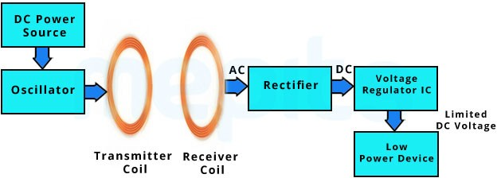
Fig.1 -BLOCK DIAGRAM O WIRELESS POWER TRANSFER SYSTEM

IV. TECHNOLOGY USED (NEAR FIELD TECHNIQUES)

INDUCTIVE COUPLING:
Two conductors are referred to as mutual-inductively coupled when they are configured such that change in current flow through one wire induces a voltage across the ends of the other wire through electromagnetic induction. In wireless transfer, a portion of the magnetic flux established by one circuit interlinks with the second circuit, then two circuits are coupled magnetically and the energy is transferred from one circuit to the another circuit The basics of this process is that the transmitter and receiver coils are inductively coupled. Oscillators are used in transmitters to convert DC current to AC current. The AC current passed in the transmitter coil generates magnetic field, which induces a voltage in receiver coil. Magnetic Field is concentrated in small volume between transmitter and receiver.

ii) RESONANT INDUCTIVE COUPLING:
Resonant inductive coupling is transmitting power between two coils that are tuned to resonate at the same frequency. Resonance occurs when the self-resonant frequency of coils equal to the frequency of AC power supply, when the equivalent circuits of coils in high frequency have the minimum impedance. Then, the most energy will be transferred from the resonant path (Ref 8). Resonant transfer works by making a capacitively loaded primary coil ring with an oscillating current. This generates an oscillating magnetic field. Because the coil is highly resonant, any energy placed in the coil dies away relatively slowly over very many cycles; but if a second coil is brought near it, the coil can pick up most of the energy before it is lost, even if it is some distance away. The fields used are predominately non-radiative (Ref 1). Magnetic resonant coupling can also be used to deliver power from a large source coil to one or many small load coils with lumped capacitors at the coil terminals providing a simple means to match resonant frequencies for the coils.

iii) MICROWAVETRANSMISSION:
Microwave transmission refers to the technology of transmitting information or energy by the use of electromagnetic waves whose wavelengths are conveniently measured in small numbers of centimetre; they are called microwaves. The wireless energy transfer with microwaves need a source of electromagnetic radiation, and a microwave receiver with a DC rectifier to transform the microwave energy into DC electrical power(Ref 11). The transmitting and receiving units has to be in line of sight. Line of sight (LoS) is a type of propagation that can transmit and receive data only where transmit and receive stations are in view of each other without any sort of an obstacle between them (Ref 12). The electrical energy is first converted into microwave energyin the transmitter which is transmitted over distance to receiver which has rectenna that converts these microwaves back into electrical energy. AC cannot be converted directly to microwave in a transmitter.

4.1 Need for wireless power transmission?

Wireless transmission is employed in cases where instantaneous or continuous energy
transfer is needed, but interconnecting wires are inconvenient, hazardous, or impossible.

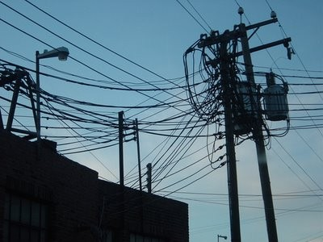
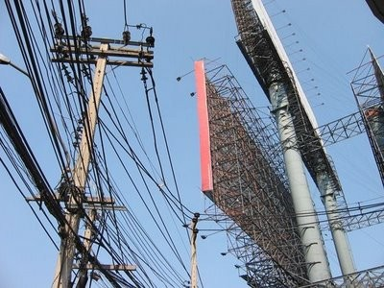
Fig no.2
Number of household points receives electricity at the same frequency using single transmitting coil as long as they all are at resonance. So this setup could recharge all the devices in a room at once.

4.2 Resonance and Wireless Power:

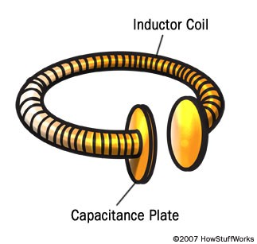
An efficient way to transfer power between coils separated by a few meters is that we could extend the distance between the coils by adding resonance to the equation. A good way to understand resonance is to think of it in terms of sound. An object's physical structure -- like the size and shape of a trumpet -- determines the frequency at which it naturally vibrates. This is its resonant frequency. It's easy to get objects to vibrate at their resonant frequency and difficult to get them to vibrate at other frequencies. This is why playing a trumpet can cause a nearby trumpet to begin to vibrate. Both trumpets have the same resonant frequency.

Fig.3

4.3 Efficiency:
The efficiency of wireless power is the ratio between power that reaches the receiver
and the power supplied to the transmitter.Researchers successfully demonstrated the ability to power a 60 watt light bulb from a power source that was seven feet (2 meters) away using resonating coils. This kind of setup could power or recharge all the devices in one room. Some modifications would be necessary to send power over long distances, like the length of a building or a city. Power transmission via radio waves can be made more directional, allowing longer distance power beaming, with shorter wavelengths of electromagnetic radiation, typically in the microwave range. A rectenna may be used to convert the microwave energy back into electricity. Rectenna conversion efficiencies exceeding 95% have been realized.

4.4 THE Direction of Electric Transmission ABOUT RESONANT WPT

MIT's research team proposed resonant WPT technology, but also in theory shows that the power transmission can do without direction. In recent years, a large number of studies have been carried out to study, which is under the coaxial parallel state, which is based on the coupled, critical coupling and over coupled square. Experimental results show that there is no direction in a certain range under the condition of over coupling. Under the condition of critical coupling and under coupling, there are some directions. The direction of the system energy transmission has a great impact on the transmission distance, transmission efficiency and so on, the research of this content is still continuing, and has not yet achieved a unified research results within the industry.

4.5 Biological Safety Problems Caused by High Frequency Electromagnetic Leakage

WPT is the transmission of energy by the coupling of high frequency electromagnetic space. According to the research that the power transmission efficiency cannot reach 100%, which is affected by the internal and external factors. The lost electric energy is consumed in the form of heat energy, and the other part is lost in the space electromagnetic transmission. According to the research, long term in the radio frequency environment, the plant body will produce genetic variation and other phenomena, the animal's heart disease, blood vessels and blood diseases will occur.

V. MECHANICAL DESIGN & Fabrication model

Magnetic flux passing the receiver Receiver and magnetic flux direction is the same
(no interlinkage magnetic flux)

(interlinkage magnetic flux)

Receiver
Receiver
Receiver

Transmitter(2D) fig no.4 Transmitter(3D)

Receiver coil (0° angle)
Power source
～
Transceiver coil 1
Selector
Receiver coil (45° angle)
Power source
～
Transceiver coil 1
Selector
Selector

(a) Downside transfer (b) L-shaped transfer

Fig no.5

VI. RESULT

6.1 Hardware part

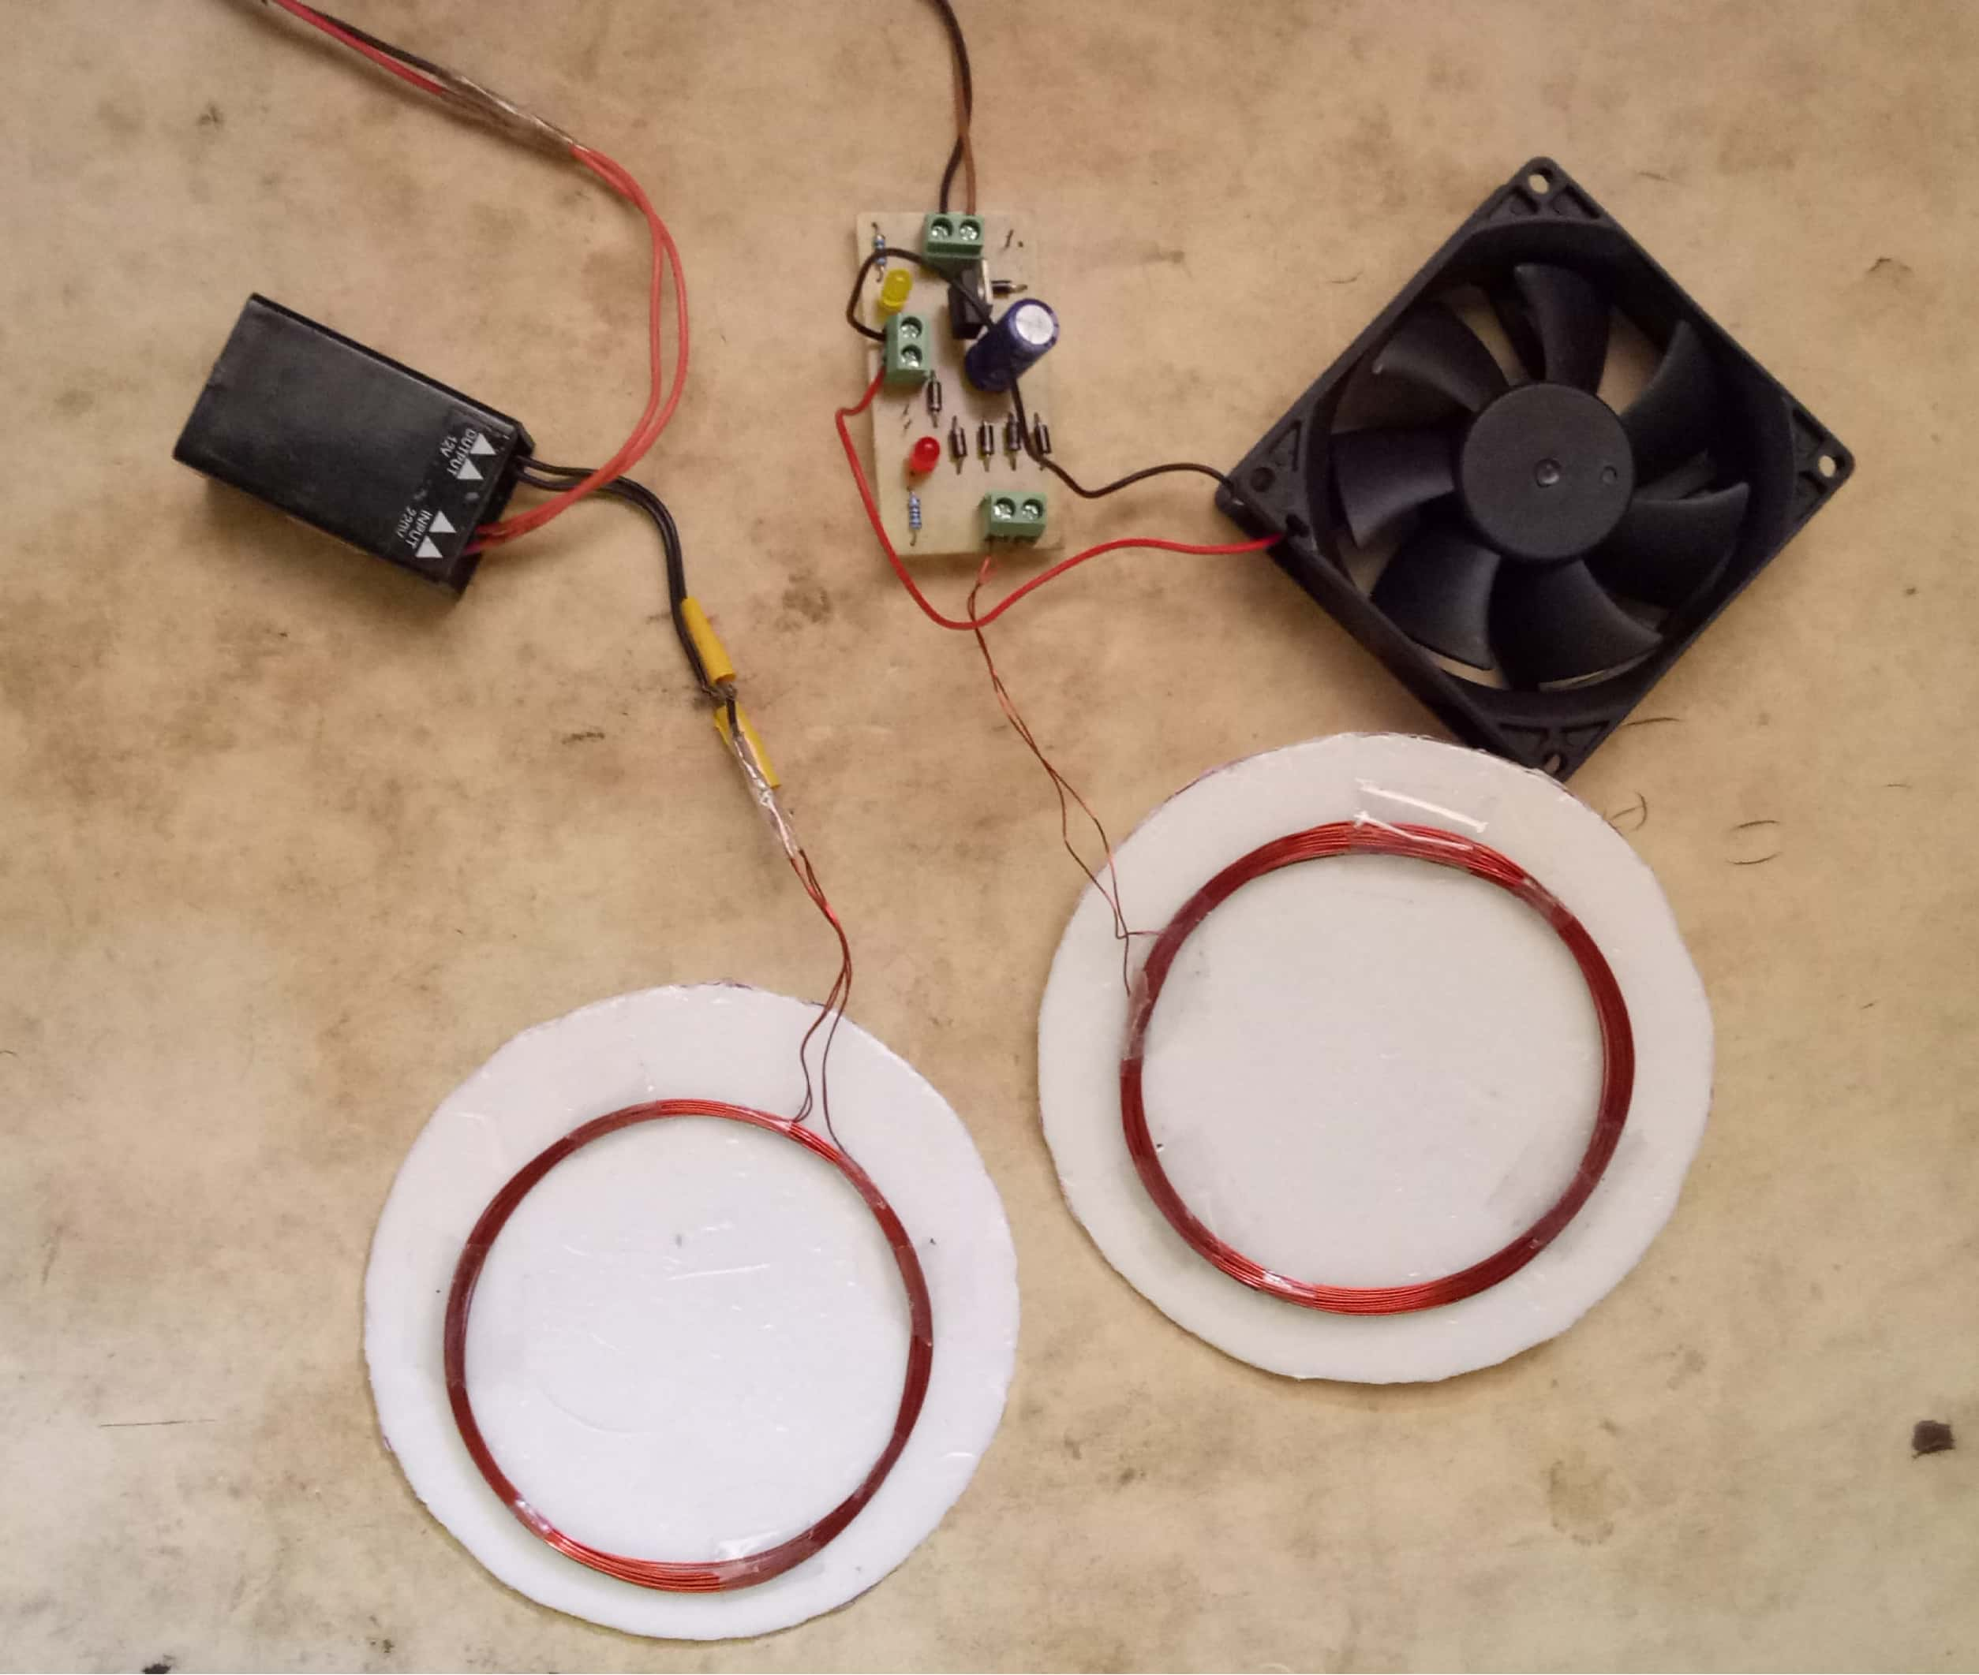
Fig.6
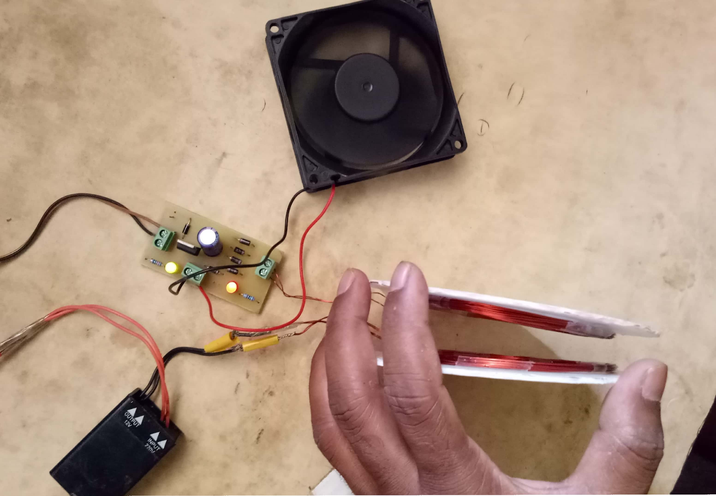

Fig. 7 Developed Model

vii. CONCLUSION

As per the proposed model, I have successfully completed the design and development of wireless power system which can able to transfer the power or electricity without any wire or connector in between transmitter and receiver using high frequency transformer and other components.This paper mainly introduces the research progress at home and abroad, and puts forward some key basic problems. There is no doubt that the research on wireless power transmission technology has made great achievements, but there are still many problems, such as energy conversion rate is low; the charging standard is not unified; the problems of biological safety; the contradiction between the cost and the wireless charging market, and so on. With the deepening of the research, the radio transmission technology will be more effective use, will be further development.

References

- M. Bowles, " State Electricity Profiles 2008," US Energy Information Administration, DOE/EIA 0348(01)/2, March 2010.
- AC Transmission Line Losses, Curt Harting, Submitted as coursework for Physics 240, Stanfo rd University, Fall 2010
- S. L. Ho, J. Wang, W. N. Fu, et al, "A Comparative Study Between Novel Witricity and Traditional Inductive Magnetic Coupling in Wireless Charging," in IEEE Transactions on Magnetics, vol. 47, 2011: 1522-1525,.
- Power loss due to Corona on High Voltage Transmission Lines Enesi Asizehi Yahaya1 Tsado Jacob2, Mark Nwohu3, Ahmed Abubakar41Departmt of Electrica and Electronics Engineering. Federal University of Technology, PMB 65, Minna,Nigeria

- Wireless Electricity Of Nikola Tesla by Melvin D. Saunders
- Wireless Charger for Low Power Devices using InductiveCoupling
A Thesis Submitted byTahsin, Naim Muhammad-Siddiqui, Md. Murtoza-Zaman, Md. Anik 1Kayes, Mirza Imrul
- Magnetic Resonant Coupling As a Potential Means for Wireless Power Transfer to Multiple Small Receivers Benjamin L. Cannon, Student Member,
IEEE, James F. Hoburg, Fellow, IEEE, Daniel D. Stancil, Fellow, IEEE, and Seth Copen Goldstein, Senior Member, IEEE
- Wireless Power Transmission Michael Shu December 9, 2011 Submitted as coursework for PH240, Stanford University, Fall 2011
- Concepts for wireless energy transmission via laser,Leopold Summerer, Oisin Purcell,ESA – Advanced Concepts Team,Keplerlaan 1, NL-2201AZ Noordwijk, The Netherlands,Leopold.Summerer@esa.int, +31-71-565-6227
- Optical Wireless Power Transmission at Long Wavelengths Aakash Sahai, Member, IEEE, David Graham

